Test case Admin
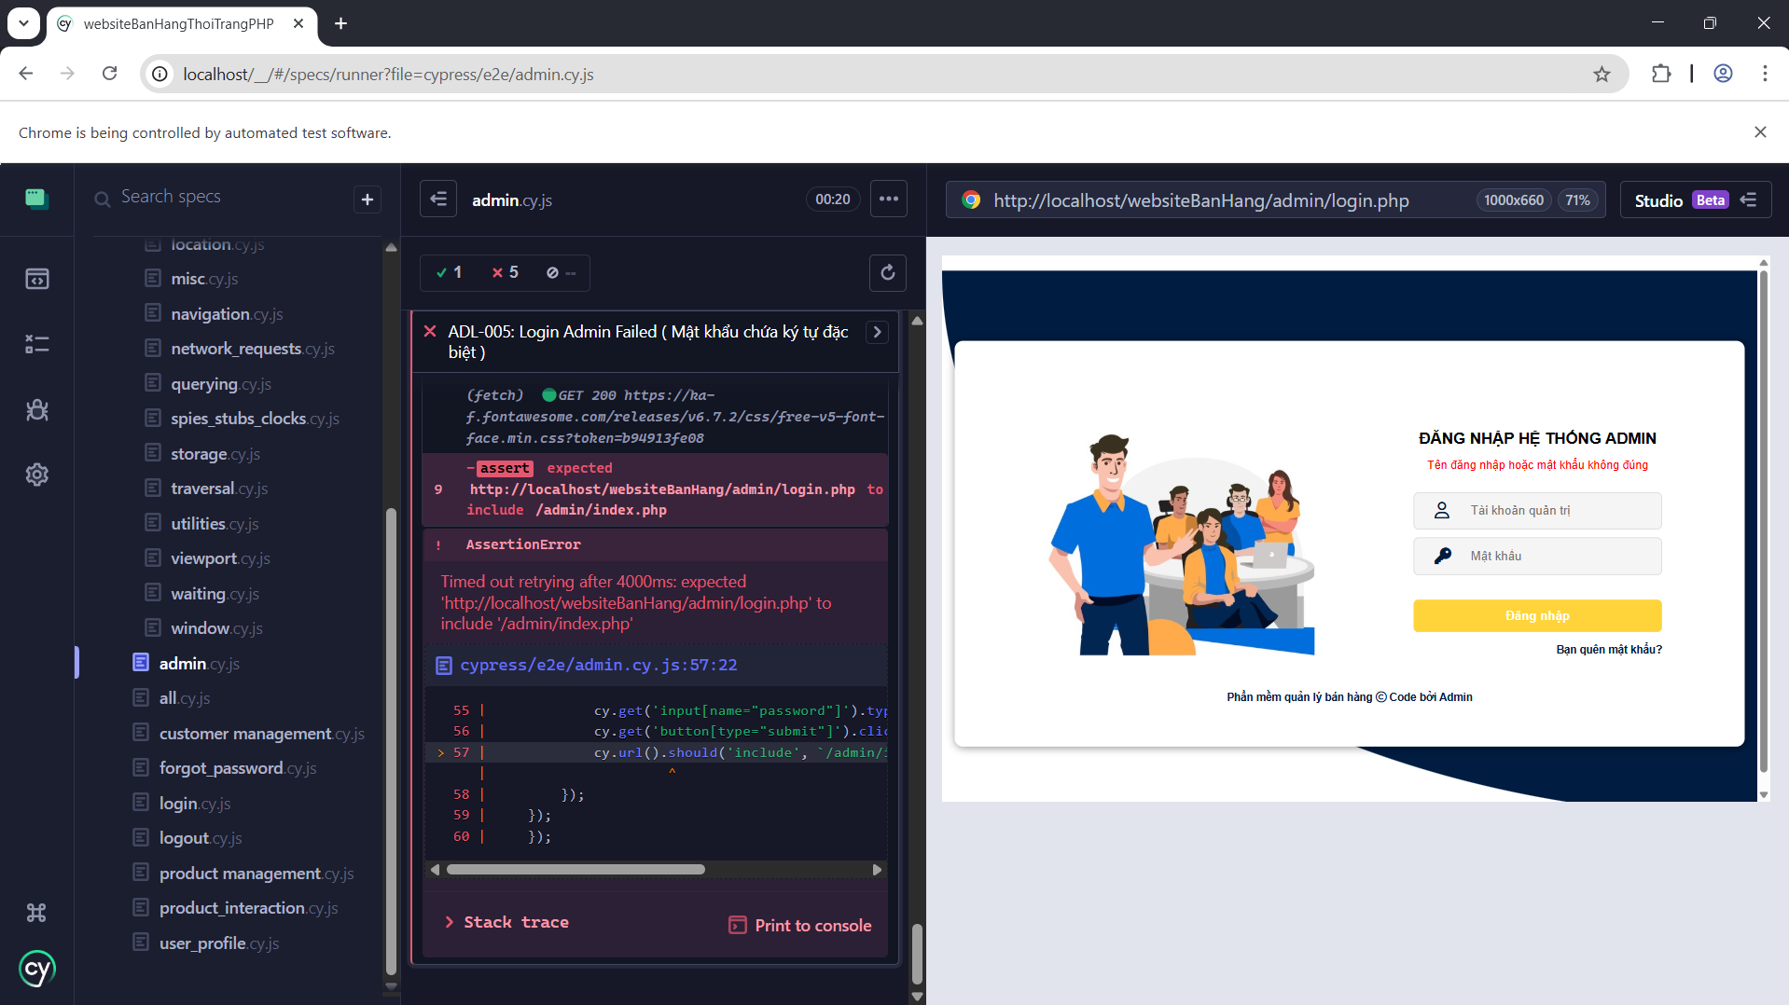
Test case Product Management
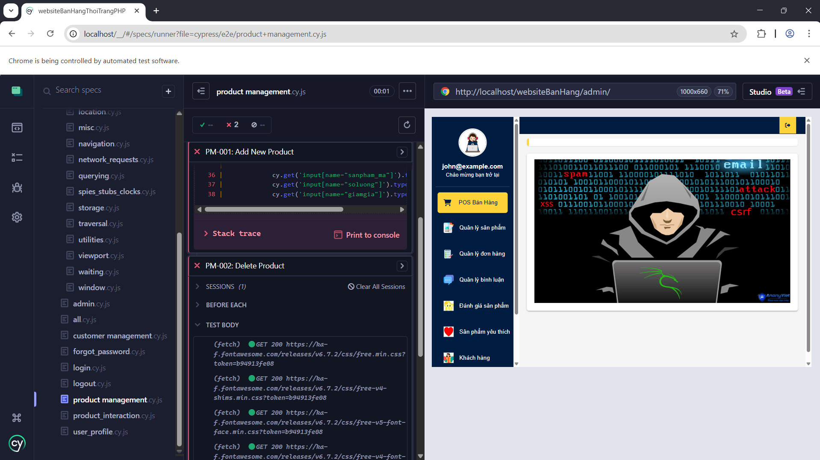
Test case Customer Management
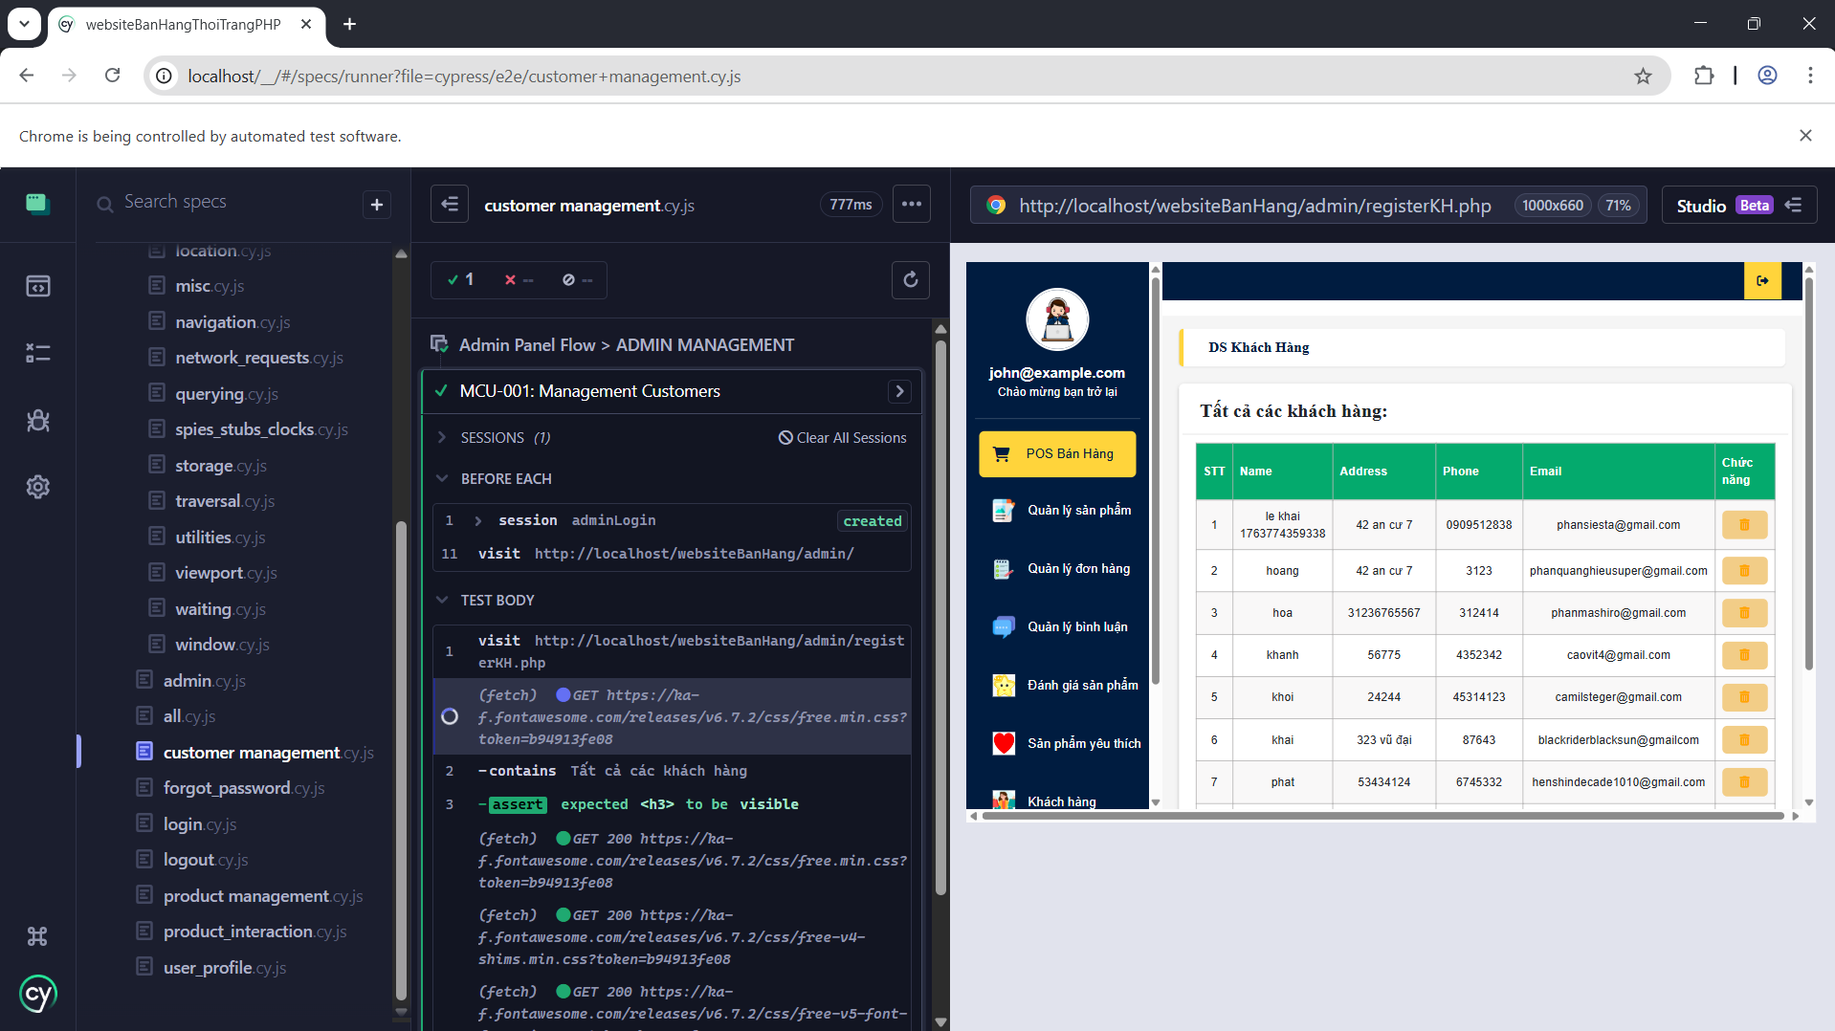
Test case Login
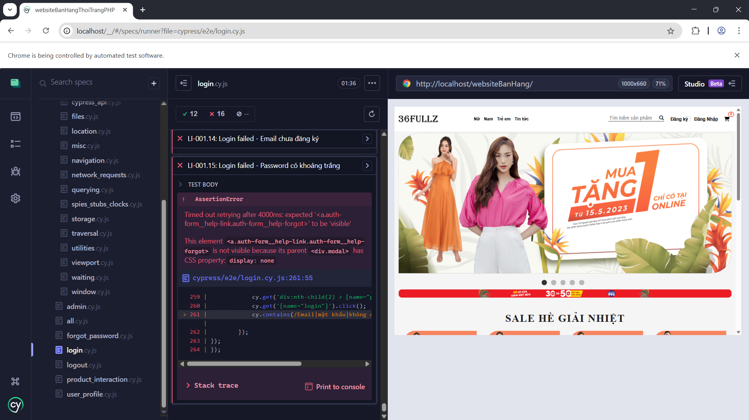
Test case Logout
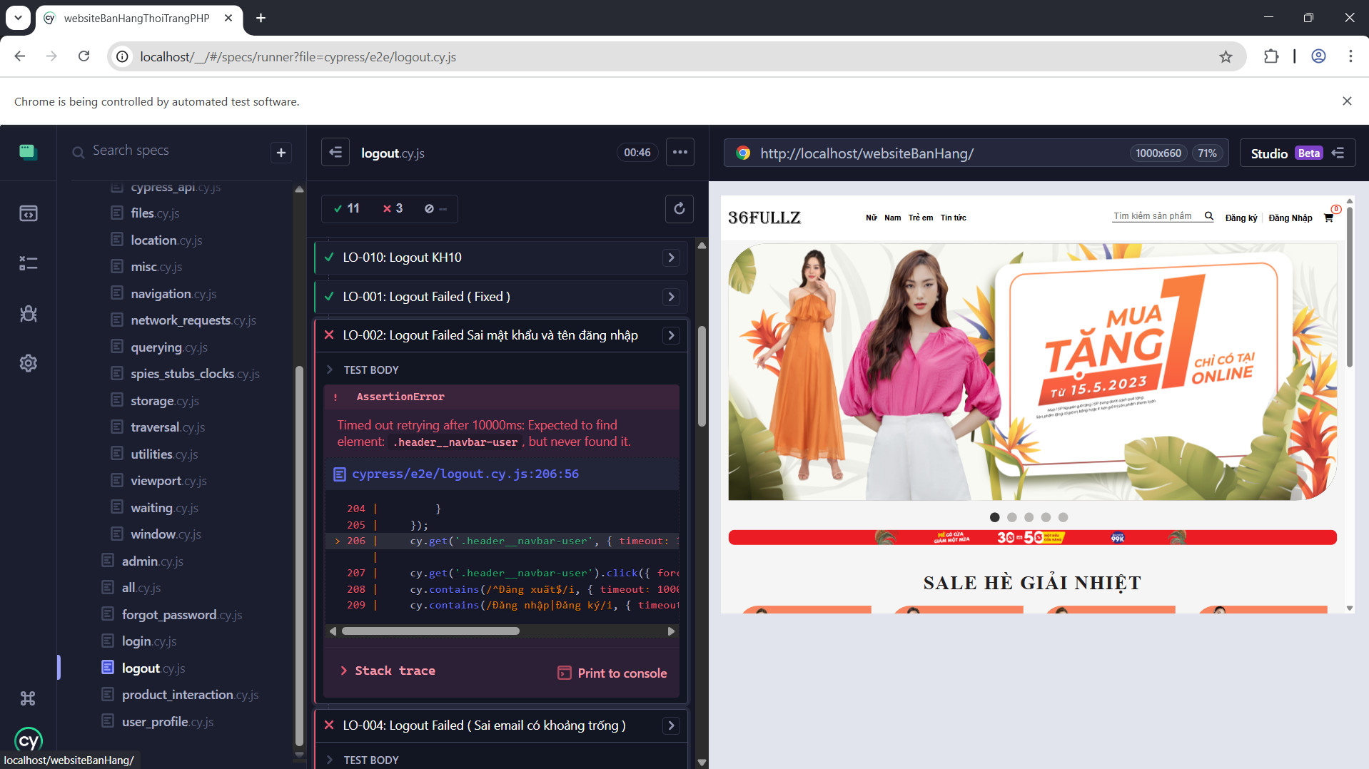
Test case Forgot password
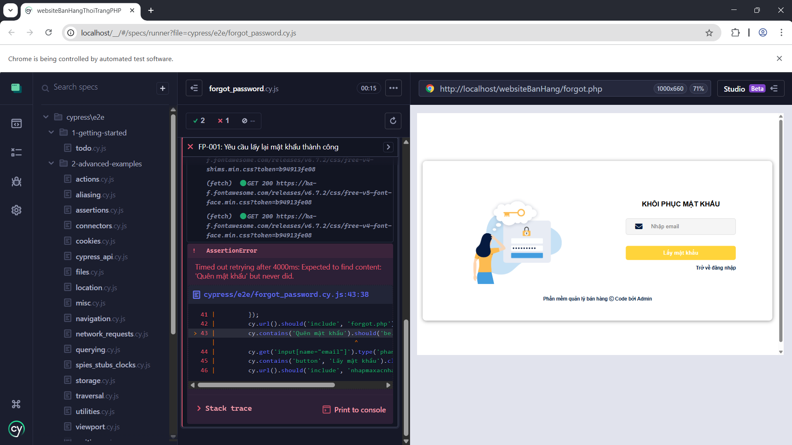
Test case Product Interaction

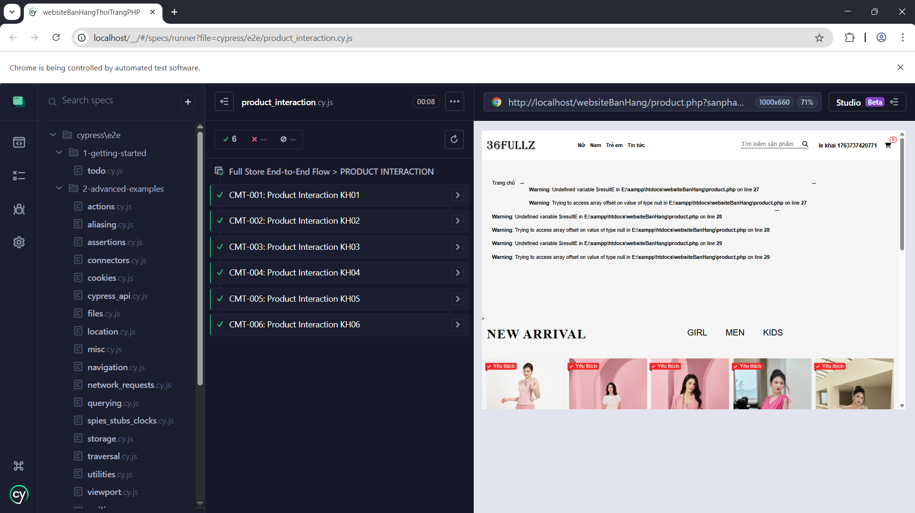
Test case Update User Profile
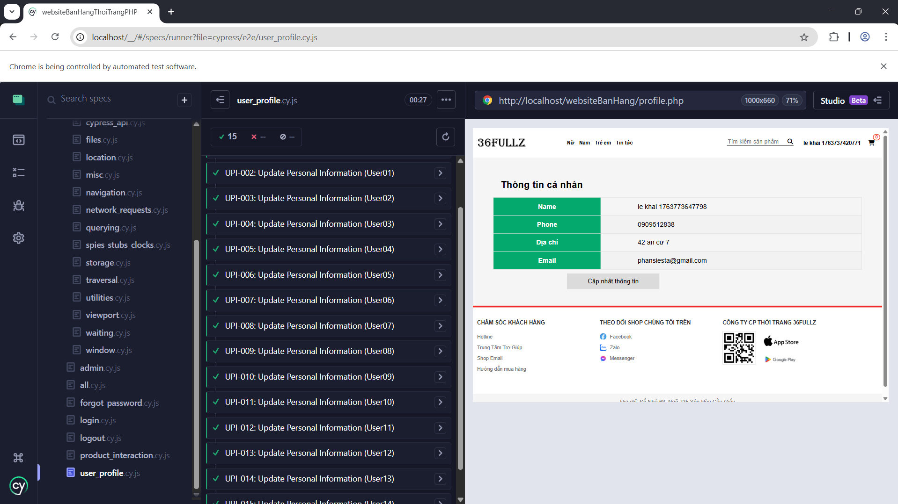
Test case All
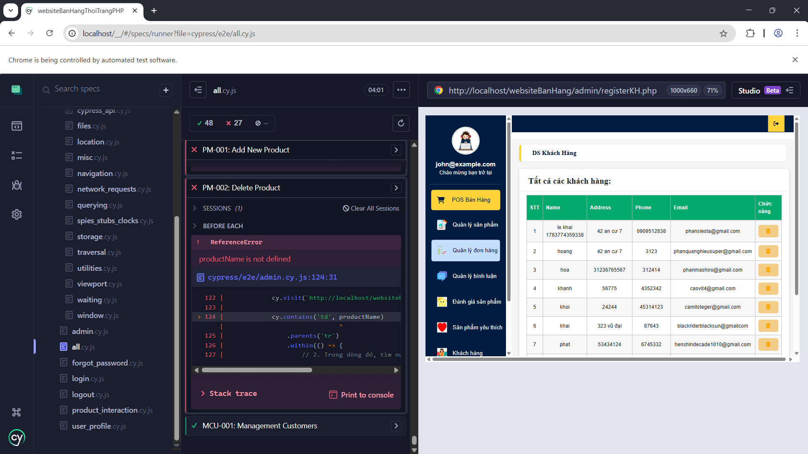
Find Test Defect
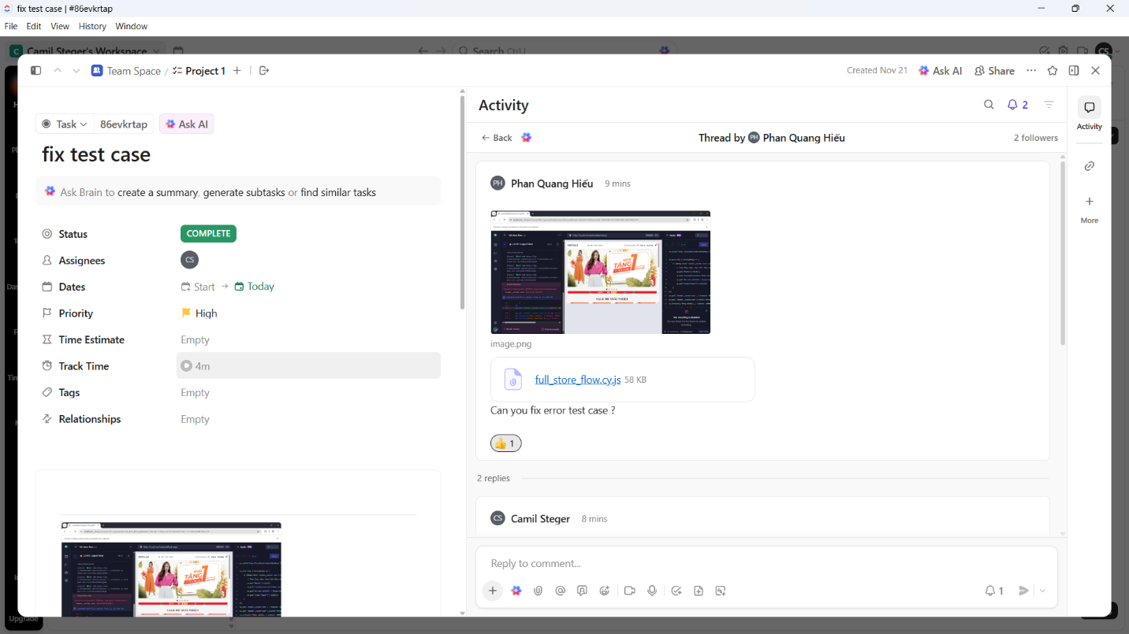
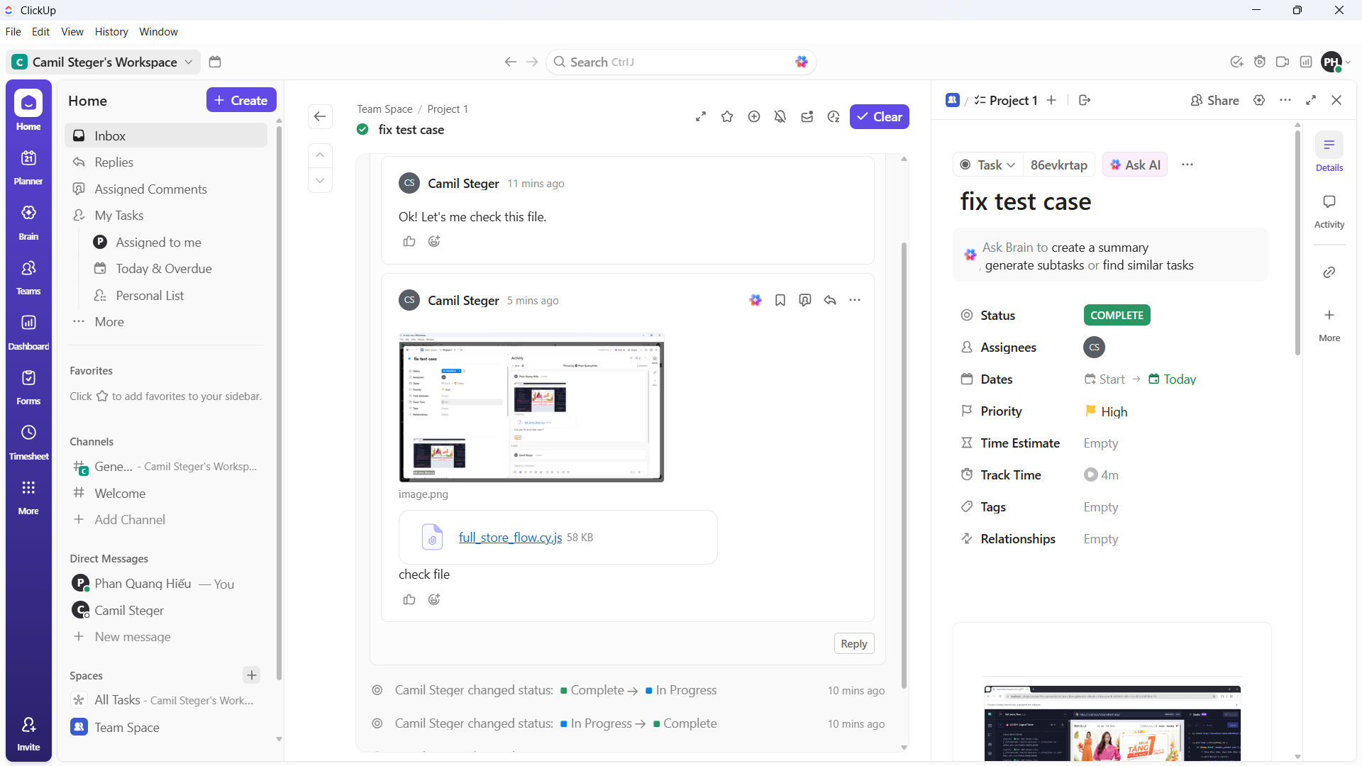
- Login
Black Box Testing – Boundary Value Analysis
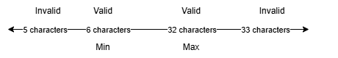
Black Box Testing – Equivalence Partitioning
Number | Input Condition | Valid Class | Invalid Class | Number
1 | Email Format | Email đúng định dạng (vd: user@gmail.com) | Missing @ (e.g., usergmail.com) | 4
 |  |  | Missing domain (e.g., user@) | 5
 |  |  | Contains forbidden characters | 6
2 | Email Existence | Email registered in DB | Email not registered | 7
3 | Password | Matches the Email | Incorrect Password | 8
4 | Empty Field | Both Email and Password have data | Empty Email | 9
 |  |  | Empty Password | 10

Black Box Testing – Decision Table Testing
Conditions | Rule 1 | Rule 2 | Rule 3 | Rule 4
Email is valid (format & exists)? | F | T | T | T
Password is correct? | - | F | T | Empty
Email is empty? | - | F | F | F
Actions | Entry
Show Error "Email invalid/not found" | ✓
Show Error "Incorrect Password" |  | ✓
Show Error "Please enter password" |  |  |  | ✓
Login Successful (Redirect) |  |  | ✓

- Product Management (SP)
Black Box Testing – Boundary Value Analysis
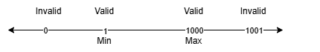
Black Box Testing – Equivalence Partitioning
Number | Input Condition | Valid Class | Invalid Class | Number
1 | Product Name | String (Letters, numbers) | Empty | 6
2 | Product Code | Unique Code | 1. Duplicate existing code | 7
 |  |  | 2. Contains forbidden special chars | 8
3 | Price | Positive Integer | 1. Negative number | 9
 |  |  | 2. Letters | 10
 |  |  | 3. Special characters | 11
4 | Image File | Format: .jpg, .png, .jpeg | 1. Other formats: .txt, .exe | 12
5 | Category | Select 1 value from list | No selection made | 13

Conditions | Rule 1 | Rule 2 | Rule 3 | Rule 4 | Rule 5
Product Name entered? | F | T | T | T | T
Product Code valid & unique? | - | F | T | T | T
Price & Quantity valid? | - | - | F | T | T
Image selected? | - | - | - | F | T
Actions | Entry
Show Error "Missing Product Name" | ✓
Show Error "Invalid/Duplicate Code" |  | ✓
Show Error "Invalid Price/Quantity" |  |  | ✓
Show Error "Image not selected" |  |  |  | ✓
Create Product Successful |  |  |  |  | ✓

